The Effects of Mass on a Cart Rolling Down an Inclined Plane

Amanda Mengotto

Classical Mechanics Lab

October 2015

**Abstract**

If a laboratory cart’s mass is increased, will the time for it to roll down an inclined plane decrease? To some, it may intuitively seem that an inverse relationship between mass and time exists. In theory, the mass should not have an impact on the time it takes a cart to roll down an inclined plane. There are a number of forces acting on the cart, however this experimental analysis considers only the mass, the angle of incline, and the time. Both the mass and the angle of incline were manipulated to determine whether any correlations exist among these variables. The results support that there is no relationship between the mass and the time, and an inverse relationship exists between the angle of incline and the time. As the angle of incline increases, the time to travel a given distance is found to decrease.

**Introduction**

As the angle of an inclined plane increases from 0° to 90°, a rolling cart’s velocity will also increase. It is intuitive that as the velocity increases, the time to travel a given distance decreases. Similarly, it may seem that as the cart’s mass is increased, the velocity will also increase. The purpose of this experiment is to determine if any relationship exists between the cart’s mass and the time to travel a given distance.

If a cart is held in place at the top of an inclined plane, it is taken for granted that the cart will roll down the ramp without being pushed, due to the force of gravity. Additionally, the cart will continue to roll and maintain its state of motion, velocity, unless it is acted on by a force.1 In downhill cart races, it is often assumed that the cart with the greatest weight, and therefore greatest mass, will win. However, as the mass and surface area of the cart increase, the air resistance will increase and the wheels will experience more rolling friction.2 Gravity is not the only force acting on the cart. The normal force, the force of gravity, air resistance, and the force of friction all affect the time it takes for the cart to travel down the inclined plane. This experiment does not consider all of the forces, but instead assumes gravity as the single force acting upon the cart.

**Procedure**

The mass of a laboratory cart was recorded, along with the mass of several metal weights to be placed in the cart. A distance of 106 cm was measured and marked on a piece of metal track. The cart was placed at the top of the metal track with the two left wheels placed in a notch to prevent the cart from veering off the track. The timer was started, the cart was released, and the timer was stopped when the front wheels of the cart had traveled 106 centimeters. The end point was marked by a styrofoam block which also stopped the cart upon impact. Two students operated two iPhone stopwatches and the average of both stopwatch results was recorded for each trial. Five trials were conducted for each mass at each angle. Five masses were tested (480g, 500g, 680g, and 980g) at five angles (3.6°, 4.4°, 5.3°, 6.5°, and 9.5°). The independent variables were the mass of the cart and the angle of incline. The dependent variable measured was time. The controlled variables include the type of cart, the type of surface the cart rolled down, and the distance the cart travelled.

**Data**

Table 1 lists the average time from the five trials at each mass at each angle. The results from this table are graphed in various ways. Fig. 1-5 represent the mass versus time at each of the five angles tested, while Fig. 6 represents the mass versus time at all angles. The standard deviation was calculated and used to create error bars in Fig. 1-5. Fig. 7 demonstrates the relationship between the angle of incline and time to travel 106cm. The graphs in Fig. 1-5 do not include lines of best fit, as there do not appear to be any trends when viewing the data at these scales. However, when the data is viewed altogether in Fig. 6, the slope of each linear trendline is near zero, indicating a very weak relationship between the mass and the angle of incline.

Table 1: Average time recorded for each mass at each angle

|  |  |  |  |  |
| --- | --- | --- | --- | --- |
|  | 480g | 500g | 680g | 980g |
| 3.6º | 3.3 | 3.5 | 3.3 | 3.2 |
| 4.4º | 2.45 | 2.35 | 2.38 | 2.37 |
| 5.3º | 1.84 | 1.89 | 1.89 | 1.83 |
| 6.5º | 1.68 | 1.68 | 1.62 | 1.58 |
| 9.5º | 1.26 | 1.26 | 1.24 | 1.25 |

Figure . The average time for the cart to travel 106cm at a 4.4° incline.

Figure . The average time for the cart to travel 106cm at a 3.6° incline.

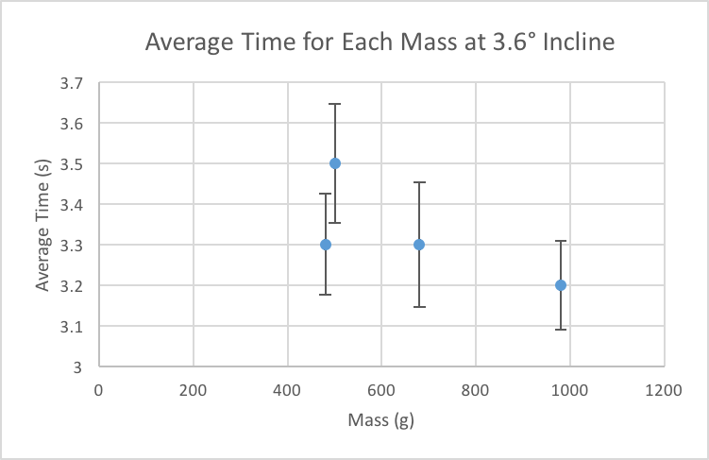

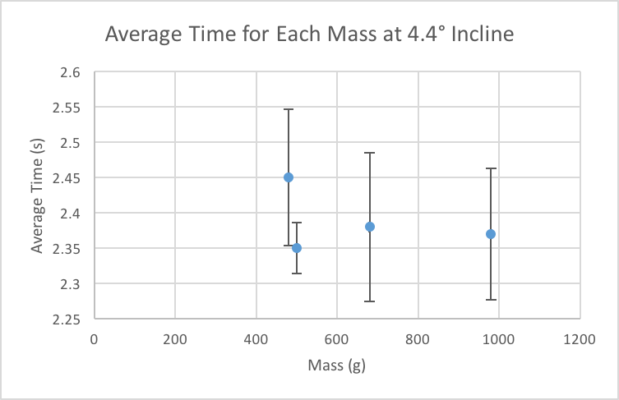

Figure . The average time for the cart to travel 106cm at a 6.5° incline.

Figure . The average time for the cart to travel 106cm at a 5.3° incline.

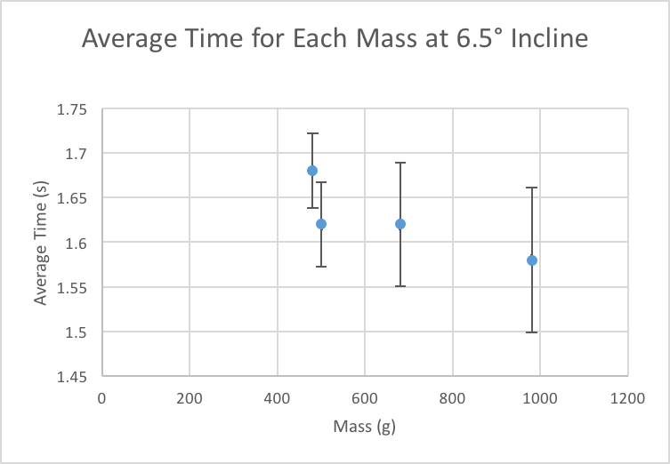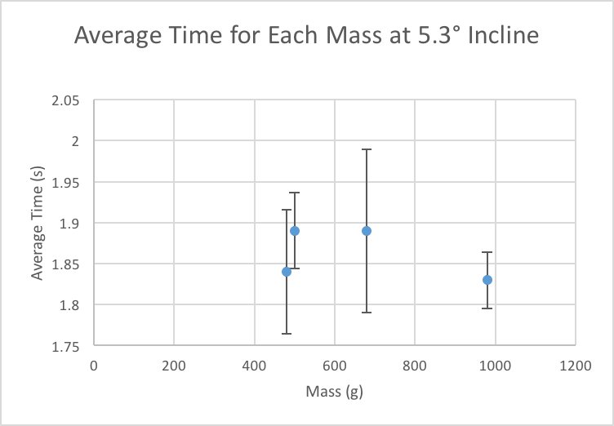

Figure . The average time for the cart to travel 106cm at a 9.5° incline.

Figure . The average time for the cart to travel 106cm at all angles of incline.

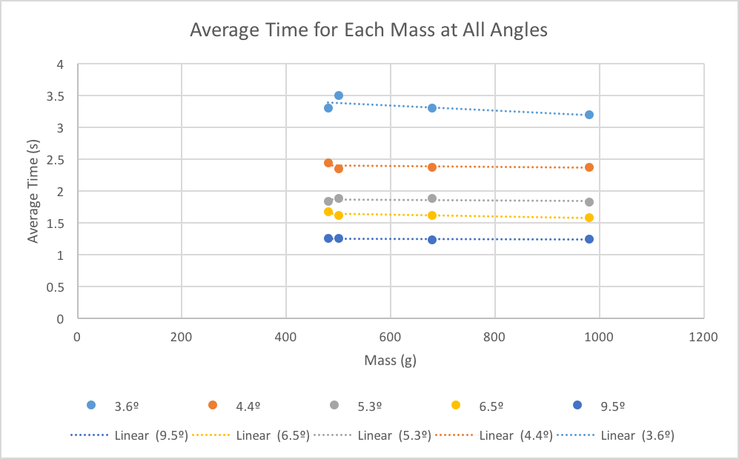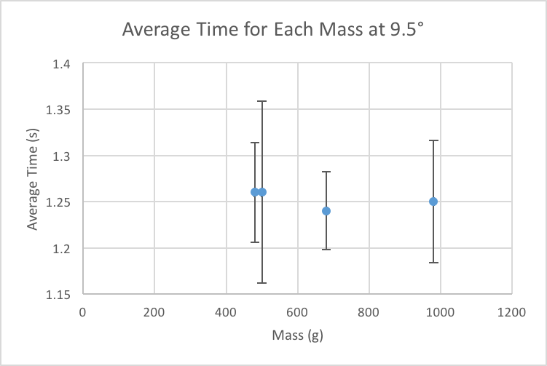

Figure 7. Average time for all masses versus the angle of incline.

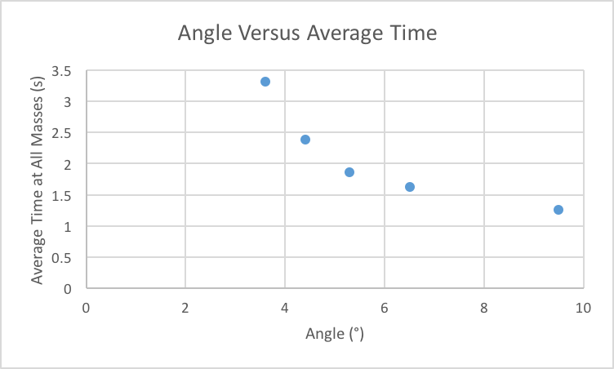

**Results**

The Mass vs. Time graphs (Fig. 1-6) demonstrate the average time in seconds for each mass at each angle of incline. Looking at the graphs, no correlation exists between the mass of the cart and the time in seconds for the cart to travel 106cm down the ramp. While it may seem as though the trendline for the 3.6° series in Fig. 6 has a negative slope, this can be explained by the fact that trials at 3.6° were the first completed, and thus our timing of the cart was not as accurate as the rest of the trials.

The Average Time vs. Angle graph (Fig. 7) demonstrates the average time among all masses, in seconds, versus the angle of incline. From Fig. 7, we can see that an increase of the angle of incline results in a decrease in time, however it is difficult to determine the mathematical relationship between these two variables.

It is clear that while the mass does not have a significant effect on the time it takes a cart to travel down an inclined plane, the angle in fact does. It may seem as though an increase in mass would result in a faster time, however it is the increase in angle that decreases the time for the cart to travel a given distance.

Notes and Bibliography

1. Giordano, Nicholas J. College Physics: Reasoning and Relationships. Pacific Grove: Brooks/Cole, 2013. Print.
2. Ibid., 40.